Novel Biorefinery (Type Your Title Here – Times New Roman 10pt Bold)

Adam A. Author¹ (underline presenting author) and Sarah Q. Author-Two²*
¹Super University, City, Province postcode (Country)
²Fundamental Research Laboratory, Excellent Company, Site Location,
City, Province postcode (Country)
*s.a-t@excellentco.com (corresponding author designated with a star)

Introduction
A short introduction should be placed here in font Times New Roman, size 8 pt. Citations should be numbered numerically in order as they appear in the text [1].

Materials and Methods
Here a brief description of chemicals and equipment should be reported, along with a description of the experimental procedures, analytical tools and methods of data analysis [2].

Results and Discussion
A report of the key results and their interpretation should be given here. A single line space should separate paragraphs and the same should separate text from tables or figures. Font size is 8 pt.

Table legends are placed above any table with left alignment.

Figures should be inserted as pictures with legend below the figure.

Table 1. Surface composition via ESCA
Catalyst | %C | %N | %Ni |  | N / Ni
Ni – A5 | 39.8 | 5.2 | 12.7 |  | 0.41
Ni –control | 24.3 | 0.2 | 18.4 |  | 0.01

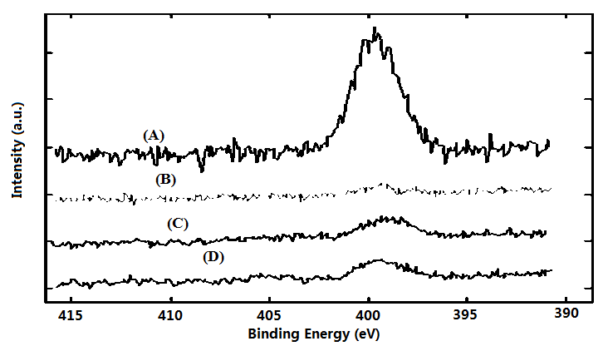
Figure 1. XPS spectra of four catalyst used in hydrogenation of chemical XYZ

Significance
Authors should highlight in 1-2 sentences significance of the work.

References
- Periana, R.A., Mironov, O., Taube D., Bhalla G., Jones C. Science 2003, 301(5634), 814-818.
- Hackshaw, A. How to Write a Grant Application; Wiley-Blackwell: Oxford, UK, 2010.

The abstract should not exceed one page.

